:росток:Beet Seed — відпрацюй навички на базовому рівні.

1. Протестуй сайт <https://www.headhunterhairstyling.com/>, знайшовши 3 баги; *запиши їх в Google docs.*

<https://anastasiialuzina.atlassian.net/jira/software/projects/H8/boards/1> - посилання на баг-репорти, нові H8-4, H8-5, H8-6

2. Створи єдиний HTML-документ з підключенням в ньому стилів трьома різними способами:

* В середині специфічного тегу (inline)
* В розділі “HEAD”
* У зовнішньому .css файлі

<https://1drv.ms/u/s!AkRZxD2OsemghDLKw1jhEmy04m0a?e=tYSeMm> - всередині тегу

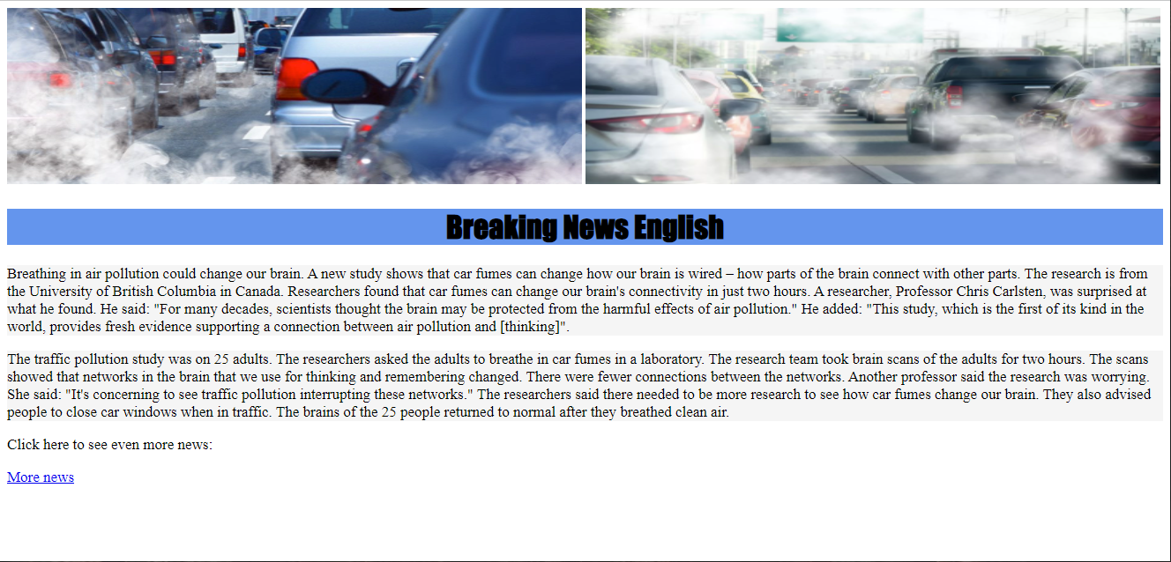

<!DOCTYPE html>

<html>

<head>

<title>Page Title</title> <img src="https://images.immediate.co.uk/production/volatile/sites/4/2019/08/GettyImages-106594948-98b6988.jpg?quality=90&resize=940,400" width="900" height="200"></title>

</head>

<body>

<h1 style="background-color:CornflowerBlue;font-family:fantasy;text-align:center"> Breaking News English</h1>

<p style="background-color:WhiteSmoke">Breathing in air pollution could change our brain. A new study shows that car fumes can change how our brain is wired – how parts of the brain connect with other parts. The research is from the University of British Columbia in Canada. Researchers found that car fumes can change our brain's connectivity in just two hours. A researcher, Professor Chris Carlsten, was surprised at what he found. He said: "For many decades, scientists thought the brain may be protected from the harmful effects of air pollution." He added: "This study, which is the first of its kind in the world, provides fresh evidence supporting a connection between air pollution and [thinking]".</p>

<p style="background-color:WhiteSmoke"> The traffic pollution study was on 25 adults. The researchers asked the adults to breathe in car fumes in a laboratory. The research team took brain scans of the adults for two hours. The scans showed that networks in the brain that we use for thinking and remembering changed. There were fewer connections between the networks. Another professor said the research was worrying. She said: "It's concerning to see traffic pollution interrupting these networks." The researchers said there needed to be more research to see how car fumes change our brain. They also advised people to close car windows when in traffic. The brains of the 25 people returned to normal after they breathed clean air.</p>

<p>Click here to see even more news:</p>

<a href="https://breakingnewsenglish.com/index.html">More news</a>

</body>

</html>

<https://1drv.ms/u/s!AkRZxD2OsemghDXW043h6dcbvE1d?e=d6IIsO> - В розділі “HEAD”

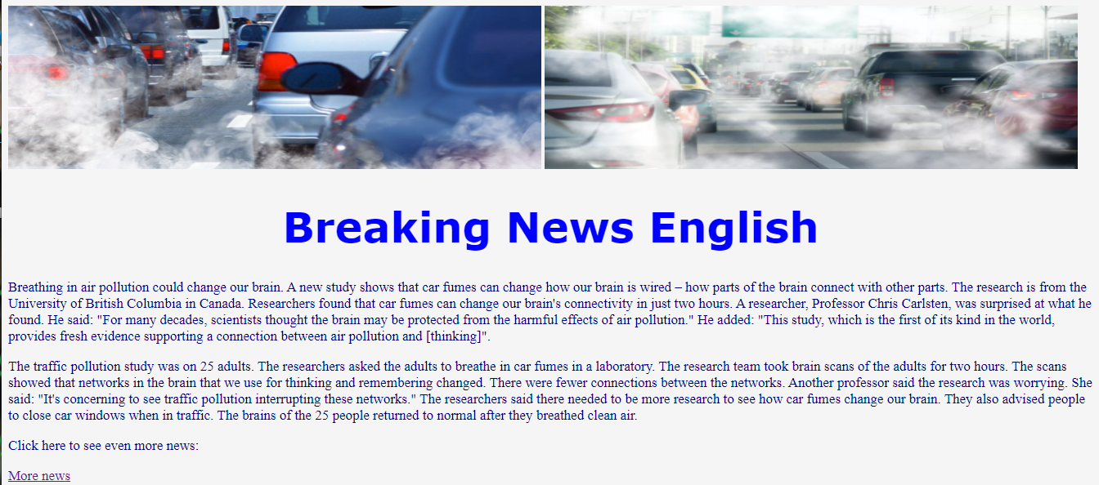

<!DOCTYPE html>

<html>

<head>

<style>

body {background-color: WhiteSmoke;}

h1 {color: blue; font-family: verdana;

font-size: 300%; text-align:center}

p {color: navy;}

</style>

<title>Page Title</title>

<img src="https://images.immediate.co.uk/production/volatile/sites/4/2019/08/GettyImages-106594948-98b6988.jpg?quality=90&resize=940,400" width="652" height="200">

<img src="https://static.euronews.com/articles/stories/07/36/12/50/1440x810\_cmsv2\_a06e2373-79b8-5d5c-8d2c-0f79f3023a34-7361250.jpg" width="652" height="200">

</head>

<body>

<h1> Breaking News English</h1>

<p>Breathing in air pollution could change our brain. A new study shows that car fumes can change how our brain is wired – how parts of the brain connect with other parts. The research is from the University of British Columbia in Canada. Researchers found that car fumes can change our brain's connectivity in just two hours. A researcher, Professor Chris Carlsten, was surprised at what he found. He said: "For many decades, scientists thought the brain may be protected from the harmful effects of air pollution." He added: "This study, which is the first of its kind in the world, provides fresh evidence supporting a connection between air pollution and [thinking]".</p>

<p> The traffic pollution study was on 25 adults. The researchers asked the adults to breathe in car fumes in a laboratory. The research team took brain scans of the adults for two hours. The scans showed that networks in the brain that we use for thinking and remembering changed. There were fewer connections between the networks. Another professor said the research was worrying. She said: "It's concerning to see traffic pollution interrupting these networks." The researchers said there needed to be more research to see how car fumes change our brain. They also advised people to close car windows when in traffic. The brains of the 25 people returned to normal after they breathed clean air.</p>

<p>Click here to see even more news:</p>

<a href="https://breakingnewsenglish.com/index.html">More news</a>

</body>

</html>

<https://1drv.ms/u/s!AkRZxD2OsemghDrTR8U9Qb4zeev7?e=Aw9Hey> - У зовнішньому .css файлі

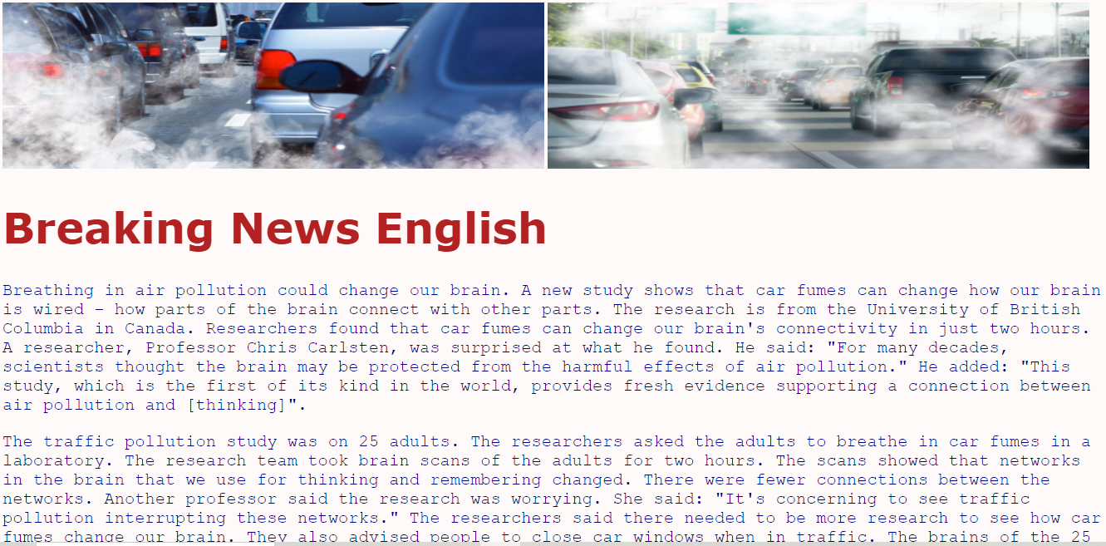

<!DOCTYPE html>

<html>

<head>

<link rel="stylesheet" href="3.css">

<title>Page Title</title>

<img src="https://images.immediate.co.uk/production/volatile/sites/4/2019/08/GettyImages-106594948-98b6988.jpg?quality=90&resize=940,400" width="652" height="200">

<img src="https://static.euronews.com/articles/stories/07/36/12/50/1440x810\_cmsv2\_a06e2373-79b8-5d5c-8d2c-0f79f3023a34-7361250.jpg" width="652" height="200">

</head>

<body>

<h1> Breaking News English</h1>

<p>Breathing in air pollution could change our brain. A new study shows that car fumes can change how our brain is wired – how parts of the brain connect with other parts. The research is from the University of British Columbia in Canada. Researchers found that car fumes can change our brain's connectivity in just two hours. A researcher, Professor Chris Carlsten, was surprised at what he found. He said: "For many decades, scientists thought the brain may be protected from the harmful effects of air pollution." He added: "This study, which is the first of its kind in the world, provides fresh evidence supporting a connection between air pollution and [thinking]".</p>

<p> The traffic pollution study was on 25 adults. The researchers asked the adults to breathe in car fumes in a laboratory. The research team took brain scans of the adults for two hours. The scans showed that networks in the brain that we use for thinking and remembering changed. There were fewer connections between the networks. Another professor said the research was worrying. She said: "It's concerning to see traffic pollution interrupting these networks." The researchers said there needed to be more research to see how car fumes change our brain. They also advised people to close car windows when in traffic. The brains of the 25 people returned to normal after they breathed clean air.</p>

<p>Click here to see even more news:</p>

<a href="https://breakingnewsenglish.com/index.html">More news</a>

</body>

</html>

3. Перевір відображення створеного документа в різних браузерах.  
3.1. Коротко опиши різницю у відображенні елементів.

1.Є різниця у відображенні стилю шрифту на різних браузерах





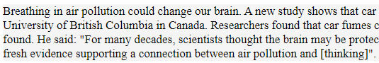

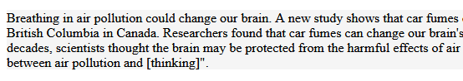

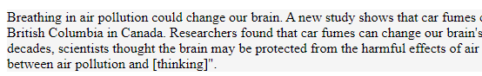

2. Різна щільніст відображення тексту



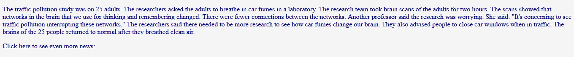

3. Насиченість кольору

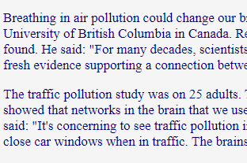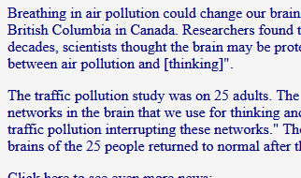

Mighty Beet — детальніше заглибся в практику.

1. Виконай завдання попереднього рівня.

2. За допомогою Developer Tools визнач кодування символів, використаних на таких вебсторінках:

* [https://beetroot.academy](https://beetroot.academy/)
* <https://microseniors76.com/>
* <https://www.tennis-warehouse.com/>
* <https://www.fidelity.com/>

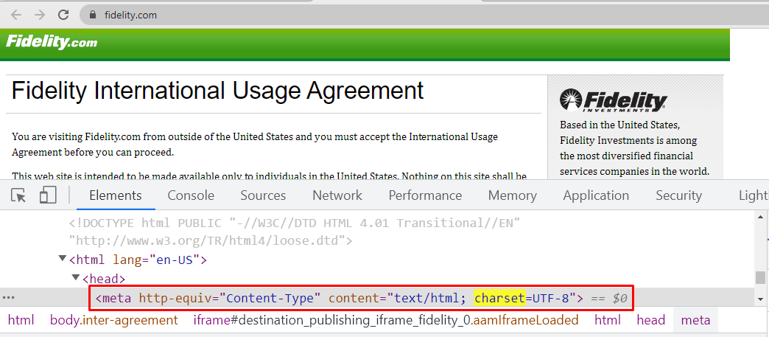

:лиственное_дерево:Mighty Beet — різнобічно опануй тематику уроку.

| 1. Виконай завдання двох попередніх рівнів.  2. На сайті <https://www.amazon.com/> знайди Xpath таких елементів:   * Logo сайту;      * Кошик;      * Language switcher;      * Поле пошуку;      * Розділ меню Gift Cards;      * Розділ меню Today’s Deals;      * Розділ меню Registry;      * Розділ меню Sell; * Розділ меню Accounts & Lists;      * Розділ меню Returns & Orders. |
| --- |